Addis Ababa University
Science Faculty
Department OF MATHEMATICS
Math 231: Applied Mathematics
Mid-Semester Examination

Date:
Time:

Name: _____________________________ I.D. No. _________________
Department: _________________________

Part A: Answer al the questions and each question carries 2 points.
- Angle between the vectors = i + 4j + k and = -i -j + 2k is ___________________________________.
- The volume V of the parallelepiped determined by the vectors
= 2i – 3j + 4k, = i + j – k and = 4i – j – k is ________________.
- The distance between the point (3, -1, 4) and the plane 2x – y + 3 = 5 is _________
- If A⁻¹ = 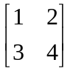, then det A = _______________ and Adj A = ______________
- Give bases for the subspace U = [(1, -2, 3), (0, 0, 5)] ________________________
- If the coefficient matrix A of a system is nonsingular, then the solution to the system Ax = 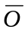is _____________________________-
- Let f(x) = 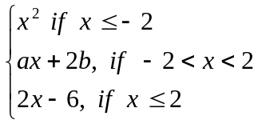. If f is continuous on ℜ, then
a = ________________________ b = ___________________
- 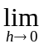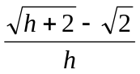 = ______________________
- 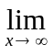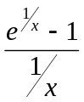 = _________________________
- 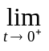 t²nt = __________________________
- If f(x) = Tanh⁻¹(sine^{x}), then ƒ′(x) = __________________________
- By using implicit differentiation, the derivative of 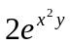 = x with respect to x at a point (2, 0) is ________________________
- The third derivative of y = x² sin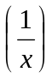 is ____________________
- If a function is not differentiable then it is not continuous (True / False) _________
- The length of the graph of f(x) = x² - n x for 2 ≤ x ≤ 3 is ______________
- 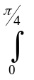Tan⁵x sec⁴x dx = _________________
- If F(x) = 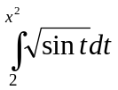, then F′(x) = ______________________
- The area bounded by the curves y = x - sinx and y = x and the lines
x = 0 and x = π is _____________________
- The value of 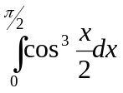 is _______________________
- 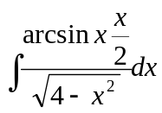 = ___________________________
Part B: Answer all the questions

- For y = x⁴ – x³ – 7x² + x + 6, determine (10 points)
  - x-intercepts, y-intercepts
  - local extreme points and values, intervals of monotonicity
  - Inflectism points and intervals of concavity
  - Asymptotes
  - Sketch the graph
- If R is the region between the graphs of y = x² and y = 2x find the volume V of the solid generated by revolving R about (i) the x-axis (ii) the y-axis (10 points)
- Determine whether the following improper integrals converge or diverge. If they converge find the values of the integrals. (10 points)
i) 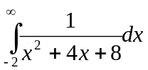 ii) 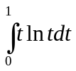
- Evaluate (i) 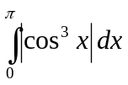 (ii) 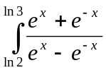dx (10 points)
- Calculate the area of the region bounded by the curves
y = -x² + 3x and y = x² + 2x – 8.

